Stage 2.1 Navigate to logic apps and build workflows

- Go to https://portal.azure.com and ensure you’re signed in to the account given to you for this session.

- Go to the Resource group created for you for this session. You will see this page below, click on the logic apps pre-created for you in this RG

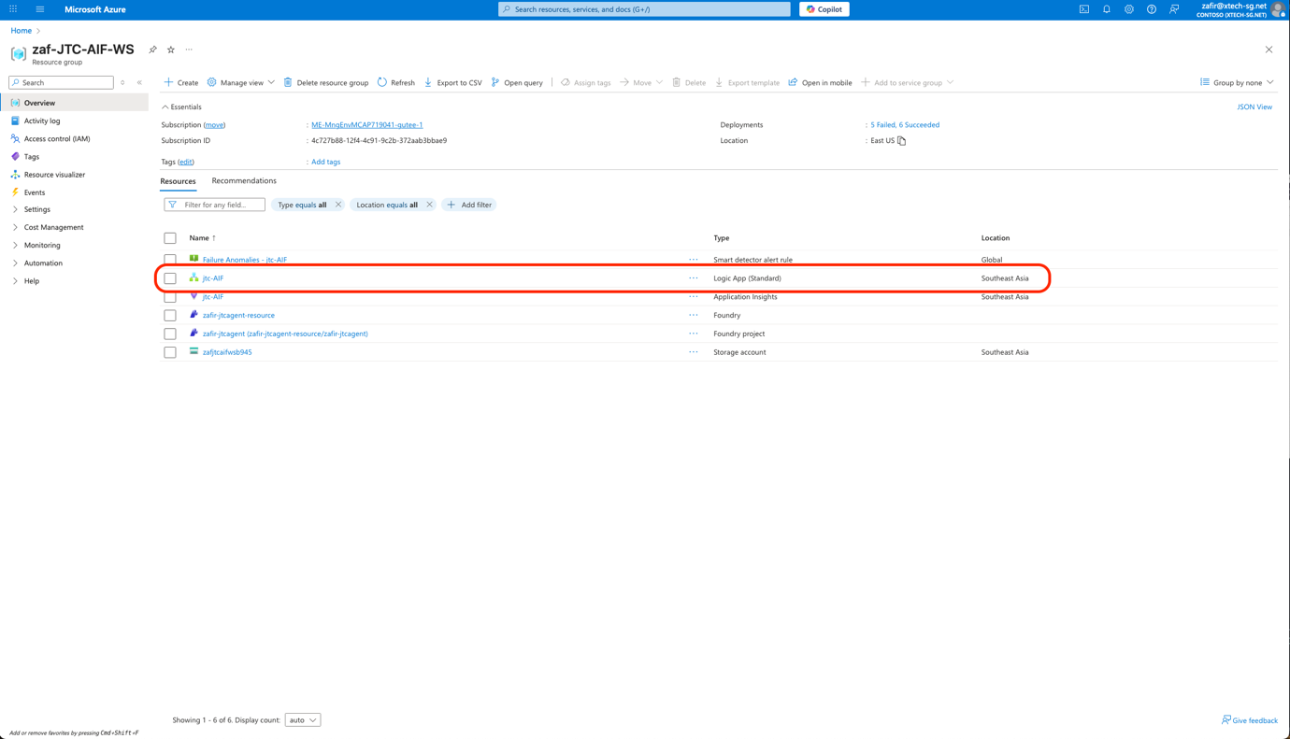

- On the logic apps page, click on “workflows” on the side pane and click “Create”

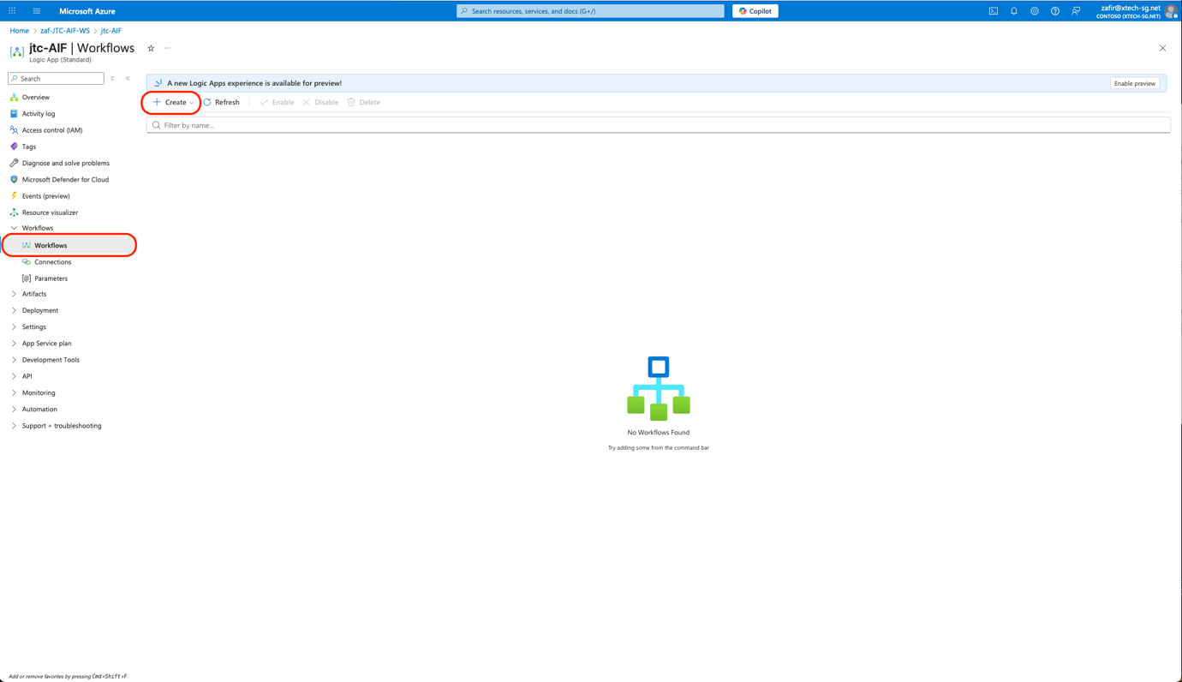

- Select “stateful” on the “Create workflow” pop up pane. And enter Name “RFP-email-automation”

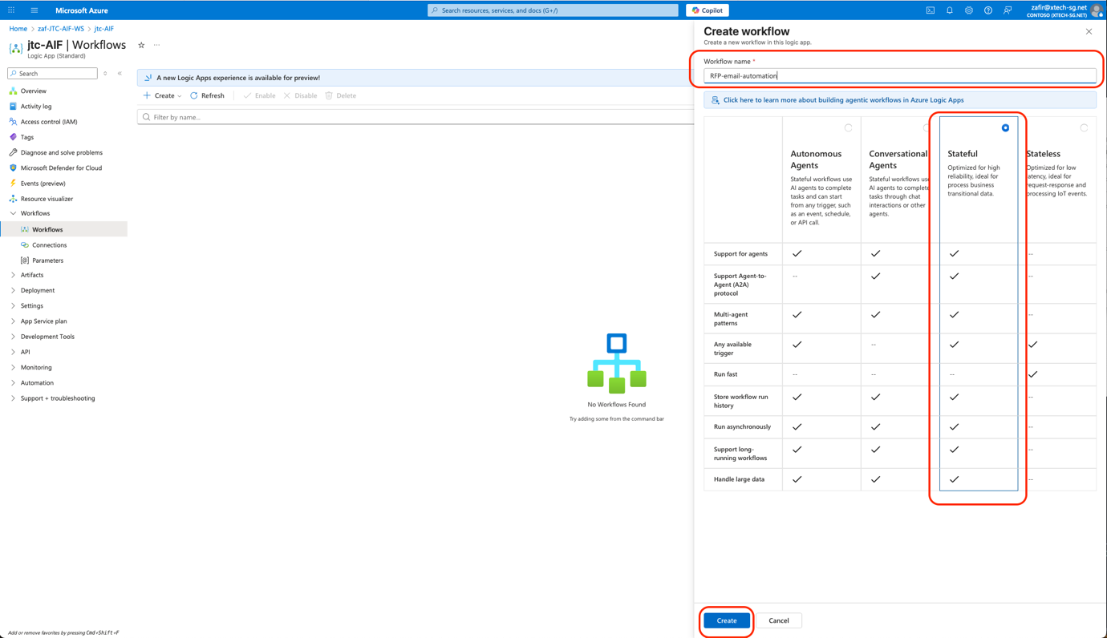

- After the workflow is created click on the “RFP-email-automation” workflow and you will be brought to the “designer” page

- Click on the “Add a trigger” node and add “when a HTTP request is made” under the “request” trigger

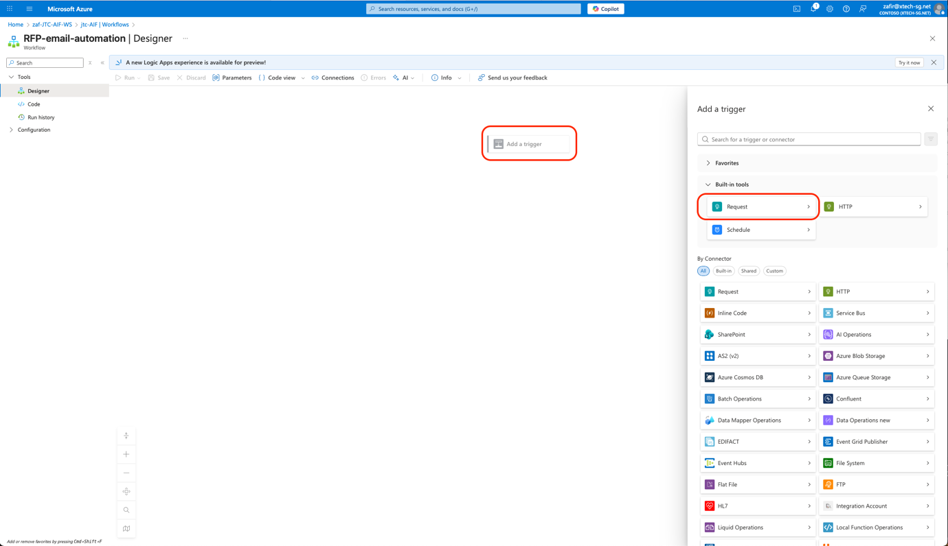

- Add this as a description for the trigger
“Use this trigger to start the RFP email”

- Under the Request Body JSON schema box, insert this schema

{
"type": "object",
"properties": {
"transactionId": {
"type": "string"
},
"action": {
"type": "string"
},
"requester": {
"type": "object",
"properties": {
"name": {
"type": "string"
},
"role": {
"type": "string"
},
"organizationName": {
"type": "string"
}
}
},
"vendor": {
"type": "object",
"properties": {
"name": {
"type": "string"
},
"email": {
"type": "string"
},
"category": {
"type": "string"
},
"serviceType": {
"type": "string"
}
}
},
"rfp": {
"type": "object",
"properties": {
"eventOrRequestTitle": {
"type": "string"
},
"eventSummary": {
"type": "string"
},
"expectedDeliveryDate": {
"type": "string"
},
"itemsSummary": {
"type": "string"
},
"notes": {
"type": "string"
}
}
},
"metadata": {
"type": "object",
"properties": {
"source": {
"type": "string"
},
"timestamp": {
"type": "string"
}
}
}
}
}

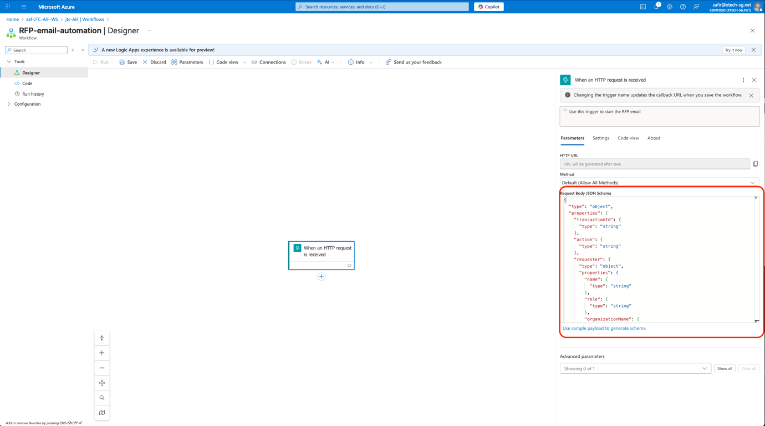

- Click the “+” icon below the trigger node and select “Add an action”. Look for the “Office 365 Outlook” connector and add a “Send an E-mail (V2)” node. The pop up side pane, will request you to sign-in. Click sign in and create the connection

- We can now configure the To and Subject as following

“To” Email: Cick the Lightning symbol that pops up and choose “see more” then select “email”

Subject: Request for quote from <fill in your team name>

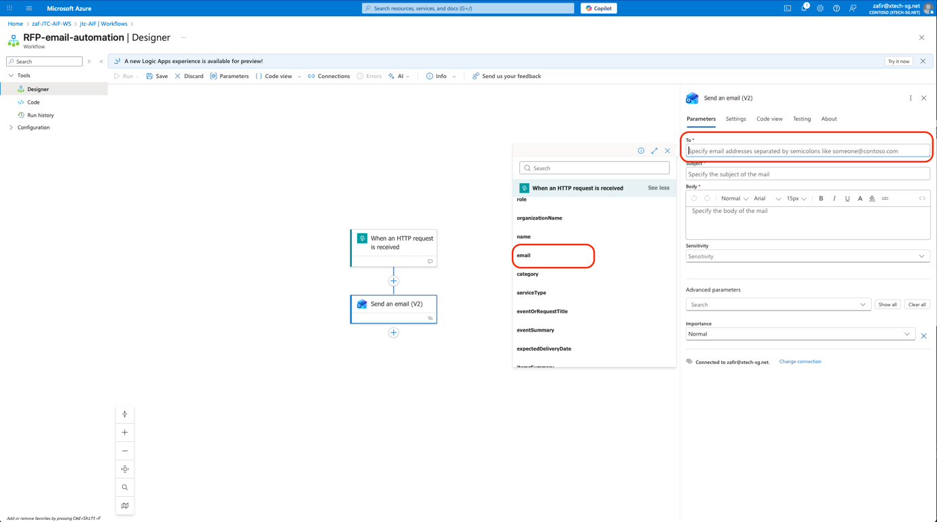

- Now let us configure the Body of the email. You may paste this template on the body section

“Hello {{VendorName}},

We are currently reviewing vendors for an upcoming requirement and would like to request a proposal from your team.

Summary of Requirement / Event
{{EventSummary}}

Items and Quantities
{{ItemsSummary}}

Expected Delivery / Service Date
{{ExpectedDeliveryDate}}

We would appreciate it if you could include the following in your proposal:
- Pricing and quotation details
- Lead times and delivery approach
- Any assumptions or dependencies
- Validity period of the quotation

If you require any clarification, please feel free to reach out.

Thank you, and we look forward to your proposal.

Best regards,
<Your team Name>”

- Change all the text in {{. }} by replacing it with the matching dynamic content. You can click on the lighting symbol and select the matching dynamic content. Refer to the image below for an example

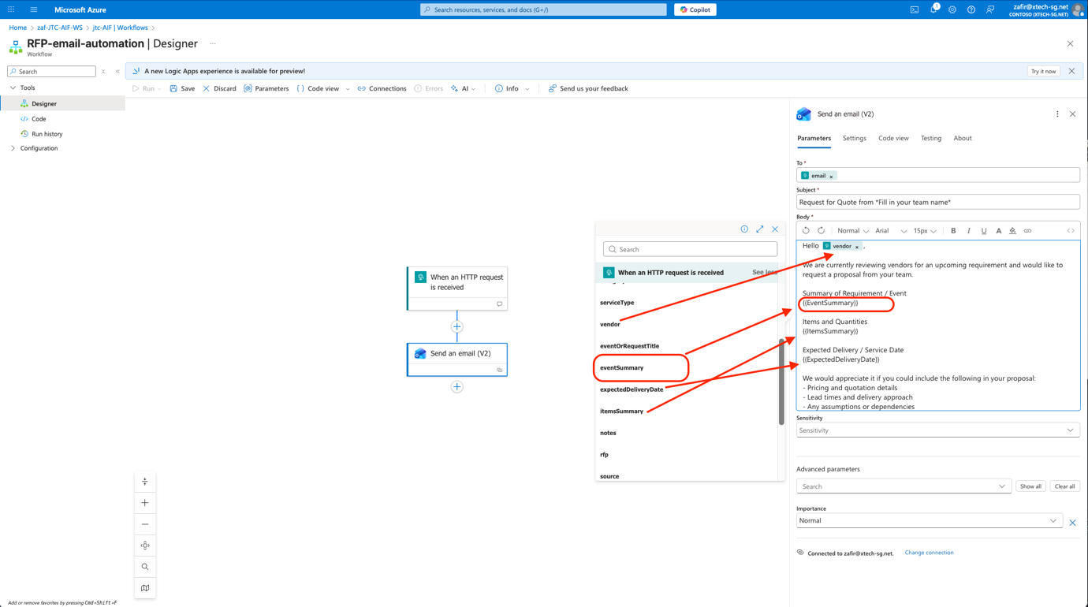

- Click save on the top task bar

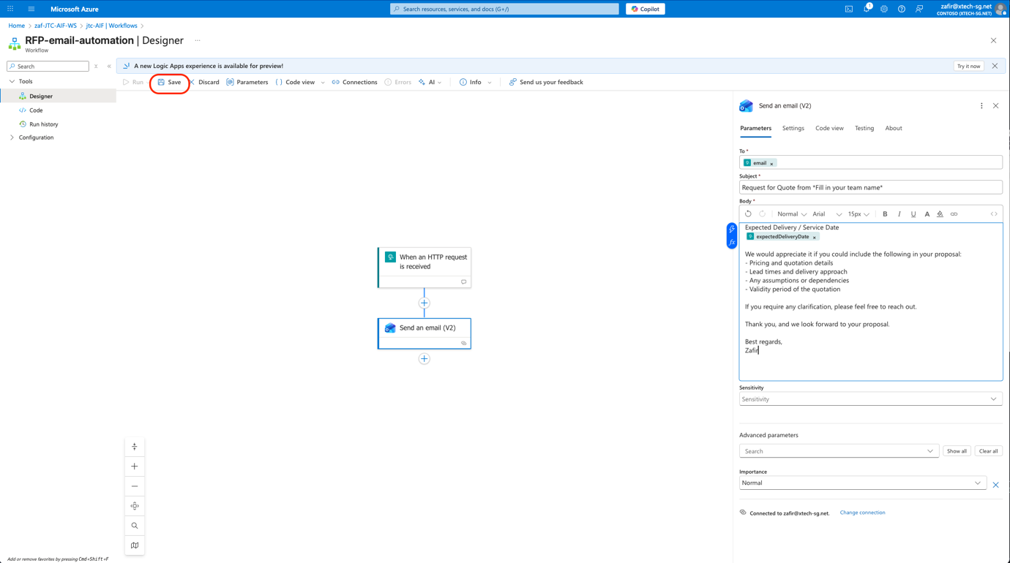

- Take note of the HTTP URL that will be generated after you have saved the workflow. This is very important

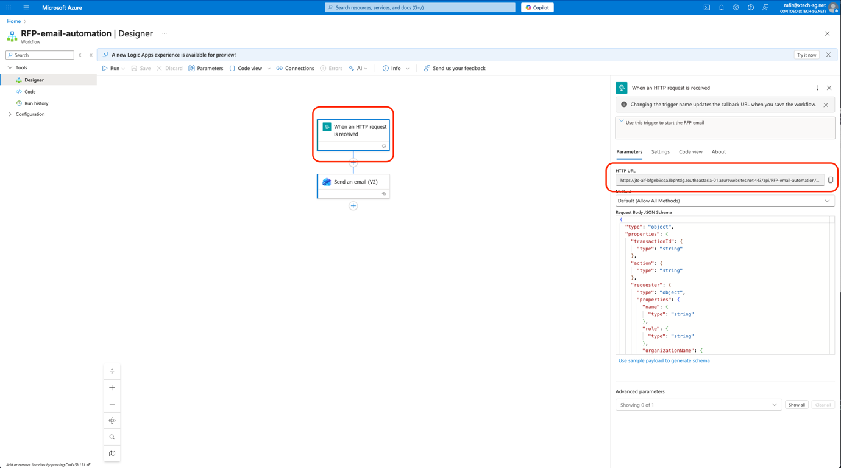

- Congratulations! You have just built the logic apps workflow that will carry out the automated RFP email! Move on to the next step to connect this workflow to our agent when you’re ready!

